Computer Networks
ASSIGNMENT 1
Name | S. Sarah Khan | Register No. | 1965260116
Submission Date | 02-11-2026 | Course | Computer Networks (CSA0708)
GitHub Repository | https://github.com/Sarah270809/CSA0708-computer-networks | Nature / Duration | Individual / 1 Week

CO1: Apply the functions of the OSI layers in enabling reliable data transmission across networks – uses of networks, network hardware and software, components, types of connections, topologies, protocols and standards, the ISO/OSI reference model, transmission media, wireless communication, Ethernet configuration, an introduction to 5G networks, and error detection, error correction and data-link control.

Assignment Title: Make the Data of a Smart Manufacturing Plant Arrive Correctly and On Time (Total Marks – 50)
Nature of Assignment: Individual
Duration: 1 Week
Submission Date: 02-11-2026

TASK 1 – Size the Traffic Before Choosing Anything
1. Traffic of one line and of the plant
Source | Working | Traffic per line
Robot controllers | 40 × (200 B × 8 bits ÷ 0.002 s) = 40 × 0.8 Mbps | 32.00 Mbps
Vibration sensors | 600 × 50 B/s × 8 = 240,000 bit/s | 0.24 Mbps
CCTV cameras | 24 × 4 Mbps (continuous) | 96.00 Mbps
Office users | 150 × 10 % = 15 active × 2 Mbps | 30.00 Mbps
Total – 1 line | 32 + 0.24 + 96 + 30 | 158.24 Mbps
Total – plant (8 lines) | 8 × 158.24 | 1,265.92 Mbps ≈ 1.27 Gbps
2. Biggest sender vs strictest delay
- Most data: CCTV, 96 Mbps = 60.7 % of the line. Strictest delay: robot controllers, 10 ms (only 32 Mbps = 20.2 %). They are not the same: the heaviest source tolerates delay, the most delay-critical source is light.
3. Is a single 1 Gbps uplink enough?
- One line: 158.24 Mbps = 15.8 % of 1 Gbps – enough. Whole plant: 1,265.92 Mbps = 126.6 % – not enough (and a safe design keeps links below ~70 % = 700 Mbps). Needs a 10 Gbps uplink (12.7 % load) or a link aggregation of several 1 Gbps links.
- Shared queue: when offered load is above link speed the queue stays full. A 1 MB buffer needs 1 MB × 8 ÷ 1 Gbps = 8 ms to drain, so a robot command waits behind CCTV frames (head-of-line blocking) and, with propagation and processing, misses its 10 ms deadline; once the buffer overflows commands are also dropped. Fix: separate VLAN and a strict-priority (DSCP EF) queue for robot traffic.
4. Delay-versus-volume comparison and ranking by harm of a 100 ms delay
Rank | Traffic | Volume (share) | Delay budget | Harm of a 100 ms delay – reason
1 | Robot commands | 32 Mbps (20.2 %) | 10 ms | 100 ms = 50 missed 2 ms commands, 10× the deadline → collisions, scrap, safety stop.
2 | CCTV video | 96 Mbps (60.7 %) | ~100–500 ms | ≈3 video frames late at 30 fps; jitter/freeze for live monitoring, but buffers hide most of it.
3 | Vibration sensors | 0.24 Mbps (0.15 %) | ~1 s | 100 ms is only 10 % of the 1 s reporting period; alarm is slightly late.
4 | Office / ERP / e-mail | 30 Mbps (19.0 %) | ≥ 150 ms | Humans barely notice 100 ms; e-mail is not time-sensitive.
Alternative Concept Analysis – motion-triggered CCTV (5 % of the time)
- CCTV = 24 × 4 Mbps × 0.05 = 4.8 Mbps. Line = 32 + 0.24 + 4.8 + 30 = 67.04 Mbps; plant = 8 × 67.04 = 536.32 Mbps (53.6 % of 1 Gbps, a 57.6 % reduction).
- Decision: the 1 Gbps uplink is no longer the bottleneck (53.6 % < 70 %), but little room remains for 1,500 devices or 5 plants, so a 10 Gbps backbone is still recommended. Costs of the alternative: local storage and motion detection, and no continuous live view.

TASK 2 – Count the Domains in the Contractor’s Drawing

1. Domain count
- Collision domains = 17: each hub with its 8 PCs and its uplink to the switch is one shared segment (3); SW1–router G0/0 (1); router G0/1–SW2 (1); each of the 12 IP-phone ports on SW2 is its own full-duplex link (12). 3 + 1 + 1 + 12 = 17.
- Broadcast domains = 2: switches and hubs forward broadcasts; only the router splits them – G0/0 side (24 PCs) and G0/1 side (12 phones).
2. Device layers and why a hub cannot stop collisions
Device | OSI layer | Why
Hub | 1 Physical | Repeats electrical bits to every port; does not read frames or MAC addresses, so all ports share one collision domain (CSMA/CD).
Switch | 2 Data link | Reads MAC addresses, learns a MAC table, buffers frames; every port is a separate collision domain.
Router | 3 Network | Reads IP addresses, forwards between networks; blocks broadcasts.
PC / IP phone | 1–7 (all) | End devices implement the full stack.
3. Point-to-point or multipoint
- Point-to-point: SW1–G0/0, G0/1–SW2, SW2–each phone, each hub–SW1 cable. Multipoint (shared): each hub segment, where 8 PCs share one medium.
4. Standards table
Technology | Standard | Body
Ethernet | IEEE 802.3 | IEEE (Institute of Electrical and Electronics Engineers)
Wi-Fi | IEEE 802.11 | IEEE (interoperability certified by the Wi-Fi Alliance)
IPv4 | RFC 791 | IETF (Internet Engineering Task Force)
OSI model | ISO 7498 | ISO (International Organization for Standardization)
5G | 3GPP Release 15+ / IMT-2020 | 3GPP specifications; ITU defines IMT-2020 requirements
Buy only standard-compliant equipment: it interoperates across vendors, avoids lock-in, is tested for safety/EMC and can be replaced or expanded without redesign.
Alternative Concept Analysis – replace the three hubs with unmanaged switches
- Collision domains: 24 PC links + 3 switch-to-SW1 links + 1 + 1 + 12 = 41. Broadcast domains stay 2.
- Fixes: collisions on the PC segments and shared bandwidth (each PC gets its own full-duplex 100 Mbps instead of sharing it with 7 others). Does not fix: broadcast traffic (still one 24-PC domain), no VLANs/QoS/security/monitoring or loop protection (unmanaged), and no layer-3 separation.

TASK 3 – Read a Captured Frame Layer by Layer
1. Layer-by-layer reading
Capture line | OSI layer | PDU | Meaning
Ethernet II | 2 Data link | Frame | Dst/Src MAC; Type 0x0800 = IPv4 inside
IPv4 | 3 Network | Packet | 10.10.1.25 → 10.10.9.4, TTL 61, Protocol 6 = TCP
TCP | 4 Transport | Segment | Port 51522 → 502, Seq 1201, Ack 88, Len 12
Data (Modbus write) | 7 Application | Data / message | 12-byte command
- Routers crossed: each router lowers TTL by 1 → 64 − 61 = 3 routers.
2. Bytes on the wire and overhead (Ethernet 14 + IP 20 + TCP 20 + FCS 4 = 58 B)
Packet | Total on wire | Overhead | Efficiency
12-byte Modbus command | 14+20+20+12+4 = 70 B | 58 B = 82.9 % | 17.1 %
1,400-byte camera packet | 1,400 + 58 = 1,458 B | 58 B = 3.98 % | 96.0 %
- Small commands waste ~83 % of the wire; large packets only ~4 %. Even the 200-byte command of Task 1 carries 58/258 = 22.5 % overhead, so 40 robots really load 40 × 500 × 258 × 8 = 41.28 Mbps, not 32 Mbps.
3. Fault → responsible layer
- (a) Wrong MAC address → Layer 2 Data link (NIC discards the frame). (b) TTL reaches 0 → Layer 3 Network (router drops it, sends ICMP Time Exceeded). (c) Closed destination port → Layer 4 Transport (host answers TCP RST).
- TCP/IP mapping: Application layer = OSI 5–7 (session, presentation, application); Transport = 4; Internet = 3; Network access = 1–2 (physical + data link).
Complete the Code – TODO 1
if tag == "ETH": pdu = "[" + tag + "|" + pdu + "|FCS]"
else: pdu = "[" + tag + "|" + pdu + "]"
print(f"{layer} adds {tag} -> {len(pdu)} bytes")
--- output ---
Application adds HTTP -> 19 bytes | Transport adds TCP -> 25 bytes
Network adds IP -> 30 bytes | Data link adds ETH -> 40 bytes
on the wire: [ETH|[IP|[TCP|[HTTP|GET /results]]]|FCS]
delivered : GET /results | overhead : 28 bytes for 12 bytes of data
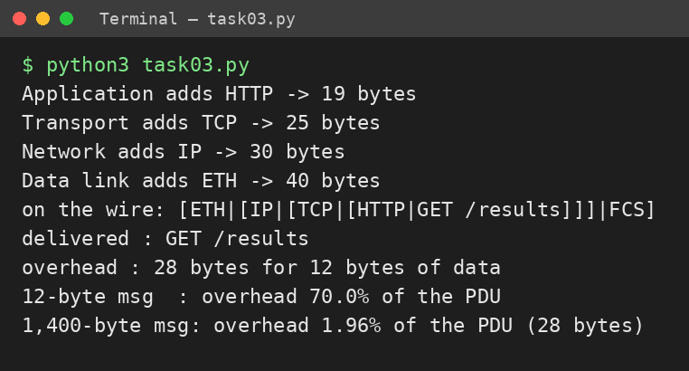
Output matches the expected output. With a 1,400-byte message: 28 B overhead = 1.96 % of the PDU, against 70 % for the 12-byte message.
Alternative Concept Analysis – command directly in Ethernet (EtherType 0x8892)
- Removing IP + TCP removes 40 header bytes, but Ethernet needs ≥ 46 B payload, so 12 B is padded: frame = 14 + 46 + 4 = 64 B. Real saving = 70 − 64 = 6 B/command (40 B only if the data ≥ 46 B).
- 100 Mbps link (adding 20 B preamble + gap): TCP/IP 90 B → 138,889 cmd/s; raw Ethernet 84 B → 148,810 cmd/s; frees ≈ 9,921 cmd/s (+7.1 %).
- Lost by giving up IP: routing (stays inside one broadcast domain, cannot reach the head office), IP addressing and firewalls/VPN, TCP reliability (ACK, retransmission, ordering, flow control) and ordinary tools/interoperability.

TASK 4 – Choose a Medium for Each Run
1. Medium for each run
Run | Medium | Deciding reason
(a) Robot cell by welders, 85 m | Cat6A S/FTP | 85 m < 100 m copper limit; foil + braid shielding rejects welding EMI (fibre if SNR still too low).
(b) Office → shop floor, 140 m | Multimode fibre (OM3/OM4) | 140 m > 100 m copper channel limit; fibre also isolates the office from electrical noise.
(c) Shop floor → data centre, 550 m | Single-mode fibre | Beyond 10G multimode reach (~300–400 m); single-mode reaches 10 km+ and takes 25/100G later.
(d) Plant → head office, 400 km | Leased line (carrier fibre) | Beyond the reach of unrepeated fibre (~10–80 km); carrier amplifiers/regenerators needed.
- The trap: copper Ethernet (100 m) cannot be used for (b), (c) or (d). Run (b) at 140 m looks only “a little over” but is still out; (c) fits 1G multimode but not 10G; (d) cannot use copper at all – nor self-installed fibre – so a carrier line is required.
2. Shannon capacity, C = B·log₂(1 + SNR)
- 250 MHz, 40 dB (ratio 10,000): C = 250×10⁶ × log₂(10,001) = 3,321.96 Mbps.
- 250 MHz, 15 dB (ratio 31.62): C = 250×10⁶ × log₂(32.62) = 1,256.95 Mbps – a 62 % drop.
- Meaning for the robot cell: noise near the welders removes 62 % of the ceiling; 1,257 Mbps is still far above the robot need (32 Mbps) but only 1.26× a 1 Gbps link, and real links reach 60–70 % of Shannon, so errors, CRC failures and retransmissions rise. Hence shielded Cat6A (or fibre) routed away from welding cables.
- Measured speed is always below Shannon because the limit assumes ideal coding; real links use finite modulation, lose power to attenuation/crosstalk, need an SNR margin, and spend bits on preamble, headers, FCS, gaps and retransmissions.
Complete the Code – TODO 1 and 2 (executed, Python 3)
def nyquist(bandwidth_hz, levels): return 2 * bandwidth_hz * math.log2(levels)
def shannon(bandwidth_hz, snr_db): snr = 10 ** (snr_db / 10); return bandwidth_hz * math.log2(1 + snr)
--- output ---
Telephone line Shannon limit 0.03 Mbps
Cat6 pair Shannon limit 3321.96 Mbps
Wi-Fi 6 channel Shannon limit 1329.50 Mbps
Nyquist, 3,100 Hz with 4 levels: 12.4 kbps
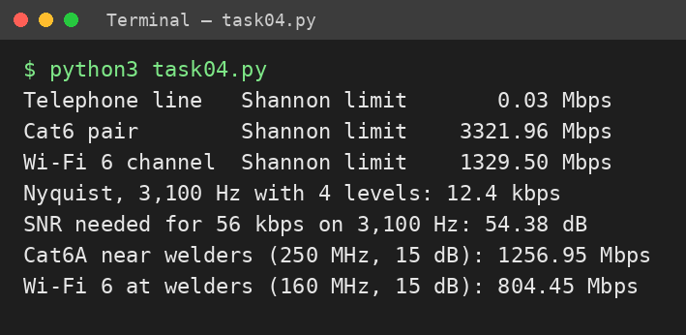
- 56 kbps on 3,100 Hz: 56,000/3,100 = 18.06 bit/Hz → SNR = 2^18.06 − 1 = 274,129 → 54.4 dB. Not realistic: a telephone line gives ~30–35 dB (≈ 30–35 kbps; 0.03 Mbps above); 56k modems worked only with a digital trunk on the server side.
Alternative Concept Analysis – Wi-Fi 6 in the robot cell
- 160 MHz, 15 dB: C = 160×10⁶ × log₂(32.62) = 804.45 Mbps (36 % below the cable). Capacity is plenty, but the problem is latency: CSMA/CA back-off, retries and interference give no 10 ms guarantee (tails of 100 ms+). Not acceptable for 10 ms robot commands; use shielded cable or 5G URLLC, and keep Wi-Fi 6 for monitoring/office use.

TASK 5 – Wi-Fi 6 or 5G for Moving Equipment?

1. Hand-overs on a 1.2 km trip at 2 m/s (trip time = 1,200 ÷ 2 = 600 s)
Measure | Wi-Fi (30 m APs, 150 ms) | 5G (300 m cell, 20 ms)
Cells along the route | 1,200 ÷ 30 = 40 | 1,200 ÷ 300 = 4
Hand-overs per trip | 39 (≈ one every 15 s) | 3 (one every 150 s)
Time not reachable per trip | 39 × 150 ms = 5.85 s (0.975 %) | 3 × 20 ms = 60 ms (0.01 %)
10 ms commands missed per trip | 585 | 6
Distance travelled “blind” (2 m/s) | 11.7 m | 0.12 m
2. 5G service type needed
Traffic | 5G service | Reason
AGVs (and robots) | URLLC | 10 ms deadline, very high reliability, mobility.
CCTV cameras | eMBB | 96 Mbps per line of continuous video – high throughput.
Sensors (600 × 50 B/s) | mMTC | Very many devices, tiny messages, battery life.
3. Where Bluetooth, Zigbee or LoRa beat Wi-Fi/5G
- Bluetooth (BLE): worker badges, handheld scanners, tool tags, headsets – ≤ 10–50 m, low power. Zigbee: mesh of battery-powered sensors, switches and lighting – ≈ 250 kbps, 10–100 m. LoRa: far, slow, battery-powered nodes such as yard, tank or warehouse monitoring – kilometres, years of battery, few kbps.
4. Could Wi-Fi 6 with fast roaming (802.11r) meet the deadline?
- 802.11r pre-shares keys so a hand-over drops from ~150 ms to roughly 20–50 ms. Even at 30 ms: 39 × 30 ms = 1.17 s, ≈ 117 missed commands per trip – each hand-over still exceeds 10 ms. Remaining risk: contention with 150 office users, welding interference, retries and tail latency, ping-pong roaming, metal-reflection dead spots, and no hard QoS guarantee. Acceptable for non-critical data, not for “never miss a command”.
Alternative Concept Analysis – LoRaWAN for the sensors
- Load = 600 × 50 B × 8 = 240 kbps versus ~5 kbps per gateway → 48× too much (4,800 %). One gateway supports only 5,000 ÷ 400 bit/s = 12.5 sensors at 50 B/s; 600 sensors would need 48 gateways (and LoRa duty-cycle limits make it worse).
- Decision: keep the continuous 50 B/s vibration sensors on Wi-Fi/5G mMTC (or wired). Move slow sensors (e.g. temperature, 50 B every 60 s = 6.7 bit/s each → ~750 per gateway) to LoRaWAN.

TASK 6 – Interpret an Ethernet Port Report
1. Reading the report
- Late collision (412): a collision detected after the first 512 bits (64 bytes) of a frame – too late for the NIC to retransmit; caused by a duplex mismatch or an over-long segment/too many hubs. CRC error (1,907): the received FCS does not match – the frame is damaged or truncated by noise or a collision.
- Combination: classic duplex mismatch. The PC is forced to 100 Mb/s half duplex with auto-negotiation off; the switch end is operating full duplex and transmits whenever it likes. The half-duplex PC sees late collisions and CRC/runt frames (2,381 rx errors), and the full-duplex switch side sees corrupted frames too – the link is “up” (Link detected: yes) but slow.
2. Likely cause and exact fix
- Auto-negotiation is off on the PC while the gigabit switch port is auto (a forced end cannot advertise duplex). Fix by returning both ends to auto-negotiation (1000BASE-T requires it) and verifying the cable:
# Linux
sudo ethtool -s eth0 autoneg on # or: speed 1000 duplex full autoneg on
ethtool eth0 | grep -E "Speed|Duplex|Auto" # expect 1000Mb/s, Full, on
ethtool -S eth0 | grep -E "err|collision" # counters must stop rising
# Windows: Device Manager > adapter > Properties > Advanced > Speed & Duplex > Auto Negotiation
3. MAC addresses
- 01:00:5e:0a:01:02: first byte 0x01 → least-significant bit = 1 → a group (multicast) address, not one device (01:00:5e is the IPv4-multicast prefix; 0a:01:02 maps to 224.10.1.2).
- 3c:52:82:4e:11:07: the first three bytes 3c:52:82 are the OUI assigned by IEEE, identifying the NIC manufacturer (look it up in the IEEE registry/Wireshark); 4e:11:07 is the unique serial of that card. First byte 0x3c has bits 0 and 1 = 0 → unicast, globally administered.
4. Jumbo frames (9,000 bytes) for the CCTV storage server
- Efficiency: 1,460 B data per 1,518 B frame = 96.2 % → 8,960 B per 9,018 B = 99.4 % (only +3.2 % bandwidth), but 6.1× fewer frames (8,960 ÷ 1,460), so far fewer interrupts and CPU load – it helps the storage server.
- Must also change: MTU 9000 on every NIC, switch port and router interface along the path (e.g. `ip link set eth0 mtu 9000`); otherwise frames are dropped or fragmented. Keep jumbo in the CCTV/storage VLAN only – a 9,000 B frame takes 72 µs at 1 Gbps (720 µs at 100 Mbps) and would delay robot packets.
Alternative Concept Analysis – ring of industrial switches vs star
 | Ring with fast recovery (e.g. MRP / RSTP) | Star of switches
Recovery time after one cut | ≈ 10–200 ms (MRP profiles); RSTP ≈ 1–2 s – traffic re-routes the other way round | None automatic: stays down until the cable is repaired (hours); dual uplinks + RSTP ≈ 1–2 s
Devices that lose connection | None permanently – ring becomes a line; only a short outage during recovery | Drop cable cut: that 1 device. Uplink cut: all devices on that switch
Cost / limits | Fewer cables, redundancy built-in; recovery time grows with ring size | Simple, easy fault-finding; uplink/core are single points of failure

TASK 7 – Will the Receiver Notice the Error?

1. CRC of 1101011011 with generator 1011 (x³ + x + 1): append 3 zeros → 1101011011000
1101 xor 1011 = 0110 -> bring down 0 -> 1100
1100 xor 1011 = 0111 -> bring down 1 -> 1111
1111 xor 1011 = 0100 -> bring down 1 -> 1001
1001 xor 1011 = 0010 -> bring down 0 -> 0100 (lead 0, xor 0000) -> 100, bring down 1 -> 1001
1001 xor 1011 = 0010 -> bring down 1 -> 0101 (lead 0) -> 101, bring down 0 -> 1010
1010 xor 1011 = 0001 -> bring down 0 -> 0010 (lead 0) -> 010, bring down 0 -> 0100 -> remainder 100
CRC = 100; transmitted frame = 1101011011100.
- Received 1101011011101: the same division leaves remainder 001 ≠ 000 → the frame is rejected (error detected; program-confirmed).
- Longest burst always detected: the generator has degree 3, so every burst of ≤ 3 bits is detected (4-bit bursts: 75 %; longer: 87.5 %). Undetectable pattern: any multiple of the generator, e.g. error 0000000001011 (= 1011 itself) – the remainder is 0, so it passes.
2. Two-dimensional parity (even) of a 4 × 4 block and the Internet checksum
Row | c1 | c2 | c3 | c4 | Row parity
1 | 1 | 0 | 1 | 1 | 1
2 | 0 | 1 | 1 | 0 | 0
3 | 1 | 1 | 0 | 0 | 0
4 | 0 | 0 | 0 | 1 | 1
Column parity | 0 | 0 | 0 | 0 | 0
- Missed 4-bit pattern: flip the four corners of a rectangle – (r1,c1), (r1,c2), (r2,c1), (r2,c2): every row and column still has even parity, so the error is accepted.
- Internet checksum: 4500 + 0073 + 0000 + 4000 = 8573 (no carry) → one’s complement = FFFF − 8573 = 7A8C (receiver: 8573 + 7A8C = FFFF ✓).
Complete the Code – TODO 1 (executed, Python 3)
if rem[i] == "1":
for j in range(len(divisor)): rem[i + j] = str(int(rem[i + j]) ^ int(divisor[j]))
--- output --- transmitted: 1101011011100 | no error: True | 1-bit error: False | 3-bit burst: False
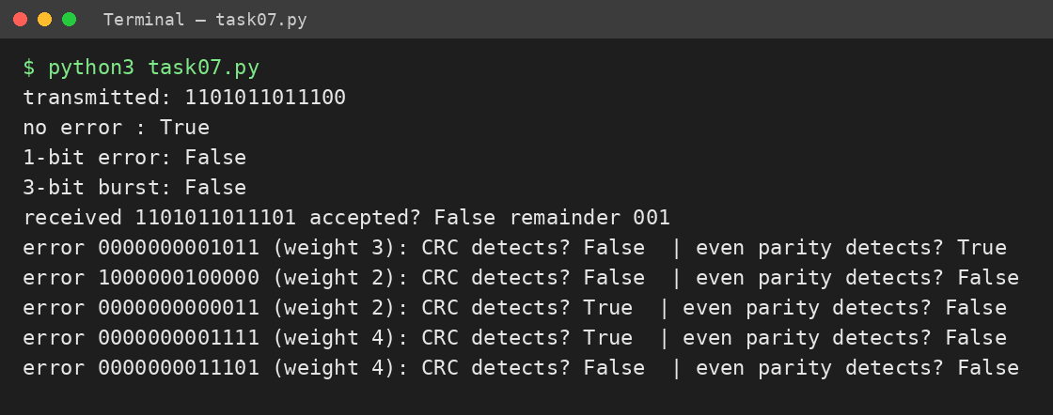
Program search: error pattern 0000000001011 gives “CRC detects? False”; so does 1000000100000 (two bits 7 apart, because x⁷ + 1 is divisible by x³ + x + 1).
Alternative Concept Analysis – even parity bit vs CRC-3 (13-bit frame)
Error pattern | Bits | Even parity | CRC-3 (1011)
0000000000011 (adjacent) | 2 | Missed (even) | Detected
1000000100000 (7 apart) | 2 | Missed (even) | Missed (multiple of G)
0000000001111 | 4 | Missed (even) | Detected
0000000011101 (= 1011 × 11) | 4 | Missed (even) | Missed (multiple of G)
0000000001011 (= G) | 3 | Detected (odd) | Missed
Parity catches every odd-weight error, including the 3-bit pattern that CRC misses, but misses every even-weight error. CRC-3 catches all 1-bit errors, all bursts ≤ 3 bits and most others, so it is stronger overall (3 check bits instead of 1).

TASK 8 – Correct the Error or Ask Again?

1. Hamming check bits for a 16-bit word (2ʳ ≥ m + r + 1)
- r = 4: 16 ≥ 16 + 4 + 1 = 21? No. r = 5: 32 ≥ 22 Yes → 5 check bits, 21-bit codeword. Overhead = 5/16 = 31.25 % of the data (23.8 % of the codeword).
2. Minimum Hamming distance of {00000, 01011, 10101, 11110}
Pair | Distance | Pair / distance
00000–01011 | 3 | 01011–10101: 4
00000–10101 | 3 | 01011–11110: 3
00000–11110 | 4 | 10101–11110: 3
- d_min = 3 → detects up to d − 1 = 2 errors and corrects ⌊(d − 1)/2⌋ = 1 error.
3. Hamming(7,4): received 0110111 (positions 1–7 = 0,1,1,0,1,1,1)
- s1 (positions 1,3,5,7) = 0⊕1⊕1⊕1 = 1; s2 (2,3,6,7) = 1⊕1⊕1⊕1 = 0; s3 (4,5,6,7) = 0⊕1⊕1⊕1 = 1 → position = 1 + 0 + 4 = 5. Flip bit 5 → 0110011 (the sent codeword); data bits (3,5,6,7) = 1011.
4. FEC or ARQ?
- On a noisy radio link a retransmission costs 40 ms, longer than any real-time deadline, so forward error correction keeps delay bounded. Video streaming and 5G use FEC because a retransmitted packet arrives too late to be useful (video), a broadcast cannot wait for every receiver, and the radio channel is noisy (5G uses LDPC/polar codes plus HARQ).
Complete the Code – TODO 1 (executed, Python 3)
s1 = c[0]^c[2]^c[4]^c[6]; s2 = c[1]^c[2]^c[5]^c[6]; s3 = c[3]^c[4]^c[5]^c[6]
pos = s1 + 2*s2 + 4*s3; if pos: c[pos-1] ^= 1; return pos, [c[2], c[4], c[5], c[6]]
--- output --- codeword : 0110011 | error at None: syndrome 0, data 1011 | error at 5: syndrome 5, data 1011
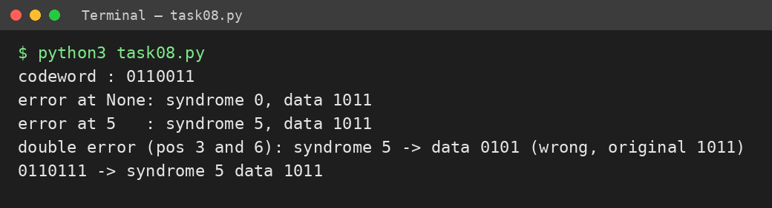
- Two bits flipped (positions 3 and 6): syndrome = 3 ⊕ 6 = 5, so the decoder “corrects” position 5 – the wrong bit – and returns data 0101 instead of 1011. Hamming(7,4) (d = 3) corrects only one error.
Alternative Concept Analysis – BER = 10⁻³, 16-bit readings
Measure | Hamming FEC (21 bits) | Retransmission ARQ (16 bits)
Probability a transmission is usable | (0.999)²¹ + 21(0.001)(0.999)²⁰ = 0.99979 | (0.999)¹⁶ = 0.98412
Average transmissions | 1.0002 | 1 / 0.98412 = 1.0161
Bits sent per reading | 21 × 1.0002 = 21.00 | 16 × 1.0161 = 16.26
Average extra delay | 0.0002 × 40 ms = 0.008 ms | 0.0161 × 40 ms = 0.65 ms
Worst case | 40 ms (rare double error) | 40 ms+ for ≈ 1.6 % of readings
ARQ sends 22.6 % fewer bits, but 1.6 % of readings suffer 40 ms spikes. FEC costs 31 % more bits yet keeps delay almost constant (0.008 ms mean), so FEC suits time-critical sensor data and ARQ suits bandwidth-limited, delay-tolerant data.

TASK 9 – How Big Must the Window Be?

1. Timing of the 400 km, 1 Gbps link (frame = 1,500 B = 12,000 bits)
Quantity | Working
Transmission time | 12,000 ÷ 10⁹ = 12 µs
Propagation time | 400,000 m ÷ 2×10⁸ m/s = 2 ms (2,000 µs)
a = propagation ÷ transmission | 2,000 ÷ 12 = 166.67
Stop-and-wait utilisation | 1 ÷ (1 + 2a) = 1 ÷ 334.33 = 0.299 % → 2.99 Mbps of 1,000 Mbps
Smallest window for full use | W ≥ 1 + 2a = 334.33 → 335 frames (≈ 502.5 KB = bandwidth–delay product)
Sequence-number bits | Go-Back-N: W ≤ 2ᵏ − 1 → 2⁹ − 1 = 511 ≥ 335 → 9 bits  Selective Repeat: W ≤ 2ᵏ⁻¹ → 2⁹ = 512 ≥ 335 → 10 bits
2. Go-Back-N vs Selective Repeat, and framing
- After one loss Selective Repeat resends 1 frame; Go-Back-N resends the lost frame and everything after it (up to ~335 frames). Cost of SR: the receiver needs a buffer for out-of-order frames (335 × 1,500 B ≈ 502.5 KB), reordering logic and per-frame ACKs/timers; the GBN receiver needs no buffer.
- HDLC marks a frame with the flag 01111110 at start and end, and uses bit stuffing (insert 0 after five consecutive 1s). PPP uses flag 0x7E and byte stuffing (0x7E/0x7D in data become 0x7D followed by the byte XOR 0x20).
Complete the Code – TODO 1 (executed, Python 3)
a = prop / tx; return min(1, window / (1 + 2 * a)), a
--- output ---
Campus LAN, 200 m, 1 Gbps a = 0.08 stop-and-wait 85.7% W=7 100.0% W=127 100.0%
City fibre, 50 km, 1 Gbps a = 20.83 stop-and-wait 2.3% W=7 16.4% W=127 100.0%
Satellite, 36,000 km, 10 Mbps a = 150.00 stop-and-wait 0.3% W=7 2.3% W=127 42.2%
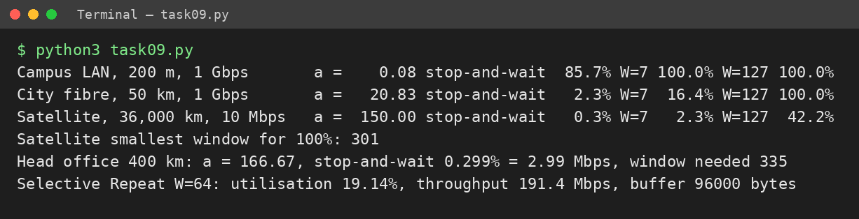
Smallest window for 100 % on the satellite link: 1 + 2a = 1 + 300 = 301 frames (W = 127 gives 127/301 = 42.2 %, matching the output).
Alternative Concept Analysis – Selective Repeat with window 64 on the 400 km link
- Utilisation = 64 ÷ 334.33 = 19.14 % → throughput = 191.4 Mbps (80.9 % of the link wasted, versus 100 % with W = 335). Receiver buffer = 64 × 1,500 B = 96,000 B ≈ 96 KB (vs ≈ 502.5 KB for W = 335). Sequence bits for W = 64: 2ᵏ⁻¹ ≥ 64 → 7 bits.
- Choice: Selective Repeat with W = 335 (10-bit numbers) for the WAN – it is the only option that fills the link, and 0.5 MB of buffer is cheap; Go-Back-N is acceptable on the LAN where a ≈ 0.08.

TASK 10 – Find Where the Delay Comes From

1. Reading the traceroute (median of three probes)
Hop | Address | Median RTT | Increase | Comment
1 | 10.10.1.1 | 0.6 ms | +0.6 | Plant gateway (private address)
2 | 100.64.0.1 | 3.1 ms | +2.5 | Carrier edge (100.64/10 shared address space)
3 | 172.31.4.9 | 4.2 ms | +1.1 | One probe 38.2 ms – outlier
4 | 103.21.8.17 | 11.8 ms | +7.6 | Largest jump – the long-haul WAN segment
5 | * * * | – | – | No reply to probes
6 | 10.200.0.10 | 12.6 ms | +0.8 | Head-office server
- Propagation: 400 km ÷ 2×10⁸ m/s = 2 ms one way, 4 ms round trip = 4 ÷ 12.6 = 31.7 % of the measured 12.6 ms. The other ~8.6 ms is equipment processing, queuing, serialisation and the real cable route being longer than 400 km.
- Hop 3 (38.2 ms once): a single delayed probe – the router answers ICMP on its slow control plane (rate-limited, low priority), or hit a transient queue; hops 4 and 6 are not slower, so forwarding is fine. Hop 5 (stars): the router is configured/firewalled not to answer TTL-expired ICMP, yet it forwards traffic (hop 6 replied). Neither is a fault.
- Most delay: hop 4 – the 3 → 4 link adds ≈ 7.6 ms (≈ 60 % of the total), consistent with the 400 km carrier link.
2. My own measurement (to attach – run on a real connection)
Windows: tracert -d <server> ping -n 20 <server>
Linux : traceroute -n <server> ping -c 20 <server>
Wireshark: capture filter "icmp or tcp port 80" while running the commands; save as Task10.pcapng
Layer / header | Fields to identify in my capture (fill in from my screenshot)
Ethernet II (L2) | Destination MAC: ________ Source MAC: ________ Type: 0x0800
IPv4 (L3) | Source IP: ________ Destination IP: ________ TTL: ____ Protocol: ____
ICMP / TCP (L4) | ICMP type/code: ____ or TCP ports ____ → ____, flags: ____
Application (L7) | Protocol / payload: ________
Ping result | min/avg/max = ____ / ____ / ____ ms, loss ____ %
Screenshots | [Insert tracert screenshot] [Insert ping screenshot] [Insert Wireshark screenshot with headers marked]
Alternative Concept Analysis – SNMP/NetFlow monitoring vs occasional ping/traceroute
Problem in the traceroute | Occasional ping / traceroute | SNMP counters + NetFlow
38.2 ms spike (hop 3) | Caught only if someone runs it at that second; a continuous ping/IP-SLA catches it within seconds | Polling averages (1–5 min) hide a single spike; shows queue drops/utilisation if a pattern develops; NetFlow shows which flows were present
Stars at hop 5 | Shows immediately but cannot tell harmless from broken | Interface and flow counters show traffic passing normally → proves no fault, no false alarm
Hop 4 high delay | Locates the hop on demand, in seconds | Utilisation/drops on the WAN link seen in 1–5 min; NetFlow names the heavy talker (e.g. CCTV vs robot traffic)
Best practice: continuous SNMP + NetFlow for trends and fast alarms, with ping/traceroute for on-demand fault localisation.

TASK 11 – Defend the Network Design

1. Recommended design, with numbers from Tasks 1–10
Area | Medium / wireless | Ethernet settings | Error + flow control, with justification
Robot cell (85 m) | Cat6A S/FTP; no Wi-Fi | 1 Gbps full duplex, auto-neg ON, own VLAN, strict-priority QoS | CRC-32 FCS + TCP on a LAN with a = 0.08 (85.7 % even stop-and-wait, Task 9). Shannon 1,257 Mbps at 15 dB ≫ 41.3 Mbps of commands (Tasks 3–4).
Office (140 m) | Multimode fibre + Wi-Fi 6 (160 MHz) | 1 Gbps full duplex, office VLAN | CRC + TCP. Wi-Fi 6 limit 1,329.5 Mbps vs 30 Mbps/line need (Task 4).
Shop floor → data centre (550 m) | Single-mode fibre, 10 Gbps | 10 Gbps; jumbo (9,000 B) only in CCTV/storage VLAN | Plant load 1,265.92 Mbps = 126.6 % of 1 Gbps → 12.7 % of 10 Gbps (Task 1); jumbo gives 6.1× fewer frames (Task 6).
AGVs / mobile | Private 5G URLLC | – | FEC (LDPC/polar) + HARQ: ARQ waits 40 ms > 10 ms deadline (Task 8). 3 hand-overs = 60 ms vs 5.85 s on Wi-Fi (Task 5).
Sensors | Zigbee/LoRa slow sensors; vibration on mMTC/wired | – | Hamming FEC: 5 check bits (31.25 %), mean delay 0.008 ms vs 0.65 ms ARQ (Task 8). 240 kbps = 48× a LoRa gateway (Task 5).
Head-office link (400 km) | Leased line 10 Gbps (2 carriers) | PPP/HDLC framing | Selective Repeat, W = 335, 10-bit sequence numbers; stop-and-wait would give only 2.99 Mbps (Task 9). a = 166.67, propagation 2 ms (Task 10).
2. The two biggest remaining risks
- Real-time wireless reliability: even 5G hand-over takes 20 ms (> 10 ms deadline) – 6 missed commands per 600 s trip – and welding/metal can degrade coverage. Mitigate with overlapping cells, dual connectivity and AGV on-board safe-stop.
- Single points of failure and capacity: one WAN line and star uplinks – a cut isolates the plant (Task 6); 1 Gbps already saturates at 126.6 %. Mitigate with a second carrier, ring (MRP) in the plant and 10 Gbps links.
3. Does it work for five plants?
- Yes, with scaling. 5 × 1,265.92 = 6,330 Mbps ≈ 6.3 Gbps in total, but only production data (not CCTV) crosses to the head office; 10 Gbps leased lines (W ≈ 335 frames) carry this. Use hierarchical addressing (a /21 per plant, /24 VLANs of ≤ 250 hosts for the 1,500 devices), the same standard-based equipment (Task 2) and local CCTV storage.
Alternative Concept Analysis – whole plant on private 5G
 | Carry on 5G | Must stay on cable
Traffic (per plant, 8 lines) | Robots 8 × 32 = 256 Mbps (URLLC), sensors 8 × 0.24 = 1.9 Mbps (mMTC), AGVs, handhelds ≈ 258 Mbps | CCTV 8 × 96 = 768 Mbps, office 8 × 30 = 240 Mbps ≈ 1,008 Mbps, plus backbone, data-centre and WAN links
Why | Mobile, flexible, low-latency; hand-overs of 20 ms suit moving devices | Fixed, continuous, high-volume video would eat the cell capacity; Shannon/EMI margins and zero-hand-over make cable more deterministic
258 + 1,008 = 1,266 Mbps (matches Task 1). Wired fall-back is kept for fixed robots where a loss of radio would stop production.

TASK 12 – Re-evaluate and Adapt the Design

Assumption for the AGV traffic: each AGV receives a 200 B command every 10 ms (0.16 Mbps) and uploads one 4 Mbps camera/lidar stream → 4.16 Mbps per AGV.
A. Impact analysis
Area | Impact | Quantified
Traffic (Task 1) | 50 × 4.16 = 208 Mbps added | Plant 1,265.92 → 1,473.92 Mbps = 147 % of a 1 Gbps uplink (+16.4 %)
Media | Uplink/backbone must be 10 Gbps single-mode; 5G radios/antennas added along the 1.2 km route | 1,473.92 Mbps = 14.7 % of 10 Gbps; 1 Gbps no longer viable
Wireless choice | Wi-Fi 6 cannot serve moving AGVs; 5G URLLC needed | Hand-overs 39 → 3 per trip (Task 5)
Error control | ARQ (40 ms retransmission) cannot meet 10 ms; radio needs FEC/HARQ | Hamming-type FEC 31 % overhead vs 40 ms spikes (Task 8)
B. Test the original design with 50 AGVs
Measure (per 600 s trip) | Original Wi-Fi 6 | Private 5G
Hand-overs per AGV | 39 | 3
Unreachable time per AGV | 39 × 150 ms = 5.85 s | 3 × 20 ms = 0.06 s
Missed 10 ms commands per AGV | 585 | 6
For 50 AGVs per trip | 29,250 missed commands; 11.7 m blind travel each | 300 missed commands; 0.12 m blind travel each
System-wide hand-overs | 50 × 39 ÷ 600 = 3.25 per second | 0.25 per second
Result: the original design fails – 99.0 % availability per AGV (5.85/600 = 0.975 % outage) cannot satisfy “never miss a command”, and 802.11r (~30 ms) would still miss ≈ 117 commands per trip (Task 5). The 1 Gbps uplink also overloads (147 %).
C. Adaptation: MODIFY (keep the wired core, change the wireless layer)
- Retain: Cat6A S/FTP in the robot cell, multimode/single-mode fibre, CRC-32 + TCP on wired links, full-duplex auto-negotiation, Selective Repeat W = 335 on the WAN, VLANs/QoS.
- Modify: 5G URLLC (5QI delay budget ≤ 10 ms) for AGVs (and optionally robots, with wired fall-back); Wi-Fi 6 for offices only; fibre backbone raised to 10 Gbps LAG; CCTV stays wired; FEC (LDPC/polar) + HARQ on 5G; 4–5 overlapping 300 m cells for conditional/dual-connectivity hand-over; on-board AGV safe-stop; ring (MRP) + second WAN carrier.
D. Evidence-based defence
- Numbers: unreachable time falls from 5.85 s to 60 ms (97.5× less); missed commands per AGV from 585 to 6; blind travel from 11.7 m to 0.12 m; uplink load from 147 % of 1 Gbps to 14.7 % of 10 Gbps, leaving room for 5 plants (5 × 1,473.92 ≈ 7.4 Gbps in total).
- Trade-offs: 5G adds spectrum/core/radio cost and specialist skills, whereas Wi-Fi 6 is already installed and cheap; 5G still cannot guarantee zero misses (6 per trip), so redundancy (dual connectivity, safe-stop) is required; redesigning everything onto 5G (Task 11) is rejected because CCTV (768 Mbps) belongs on cable. Decision: MODIFY – a full redesign is unnecessary.
- This report with the evidence for Tasks 1–12: requirement tables, diagrams, calculations, Wireshark captures, measurements and evaluations.

